EC2 PURCHASING OPTIONS

There are the following purchasing options for EC2:

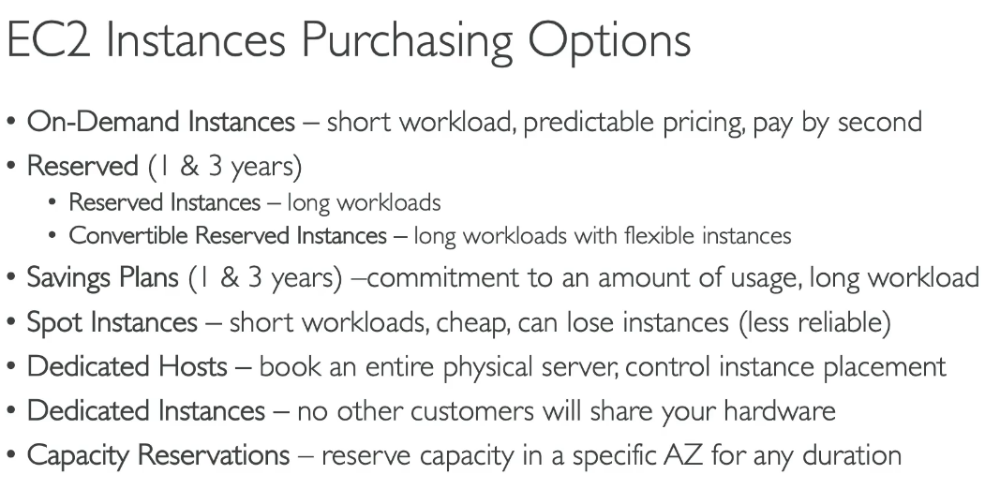

1.**On-Demand:**allow us to run instances on demands,that means they're good for short workloads, we get predictable pricing, and we're going to pay by the second.But if you have different kind of workloads, you can optimize your discounts and your pricing by specifying it to AWS.

2.**reserved instances**: have one year or three years term, and they're meant for long workloads. if you know you're going to run a database for a long time, then a reserved instance is great.

3. **convertible reserved instances** :if you want to have a flexible instance type,so for example, you want to change the instance type over time,

4. **savings plan:**one and three years term,and they're more modernbecause instead of committing to a specific instance type,you commit to a specific amount of usage in dollars,and there again, for long workloads.

5.**Spot instances** instead are meant for very short workloads, they're very, very cheap, but at any time you can lose these instances and that makes them less reliable.

6.**Dedicated host** allows you to book an entire physical server and control instance placements. And dedicated instances means that no other customers will share your hardware.

7.**capacity reservations:** allow you to reserve capacity in a specific AZ for any duration.

**EC2 on-demand**

* So you're going to pay for what you use.that means that if you're using Linux or Windows,you're going to be getting a billing per second after the first minute, or for all the other operating systems, you're going to get a billing per hour.
* It has the highest cost but no upfront payments and no long-term commitments.
* That means it's definitely recommended for a short-term and uninterrupted workload where you cannot predict how the application will behave.

**Reserved instances**,

So the reserved instances give you a 72% discounts compared to on-demand. And you reserve a specific instance attributes. For example, the instance type, the region, the tenancy, and the OS.

* You specify a reservation period one year or three years, to get even more discounts,
* and whether or not you wanna pay upfront, partially upfront, or not upfront.And all upfront of course gives you the maximum amount of discounts.
* In terms of the scope,do you want the scope to beinto a specific region or a zone?That means reserve capacity in a specific AZ.
* And so you would use reserved instances for the steady-state usage applications, think for example, for a database.
* And you can buy or sell your reserved instancesin marketplace if you don't need them anymore.

**convertible reserved instance**

And there is a specific kind of reserved instances which is allowing you to change the instance type,

the instance family, the operating system, the scope and the tenancy.And because you have more flexibility, well you get a bit less discounts you get up to 66% discounts.So that's for reserved instances.

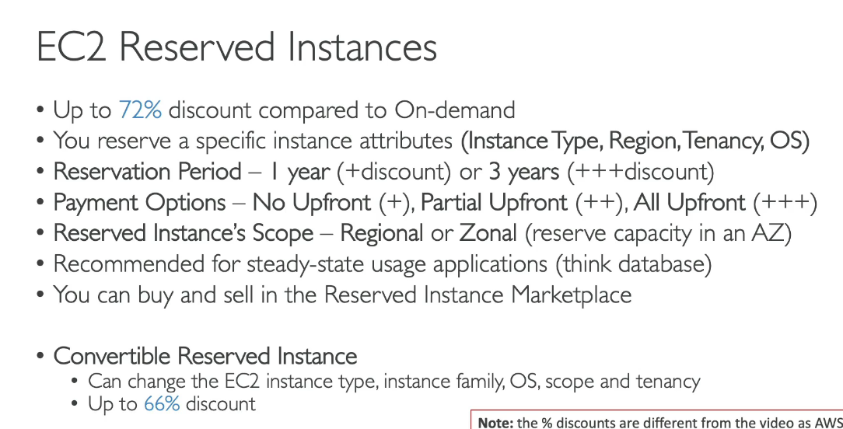

**EC2 savings plans**

which is to allow you to get a discount based on long-term usage, which is the same 70% as reserved instances. But instead, you're going to say, "I want to spend $10 per hour for the next 1, 2, 3 years. "And any usage beyond the savings plan is going to be billed at the on-demand price.

* So with savings plans,you're locked to a specific instance family and region.For example, you say,"I want to have M5 type of instance family in us-east-1.
* "But you're flexible across the instance size.So you can have m5.xlarge, m5.2xlarge and so on.
* The OS, so you can switchbetween Linux and Windows and so on.
* And the tenancy, you can switch between host, dedicated and default.

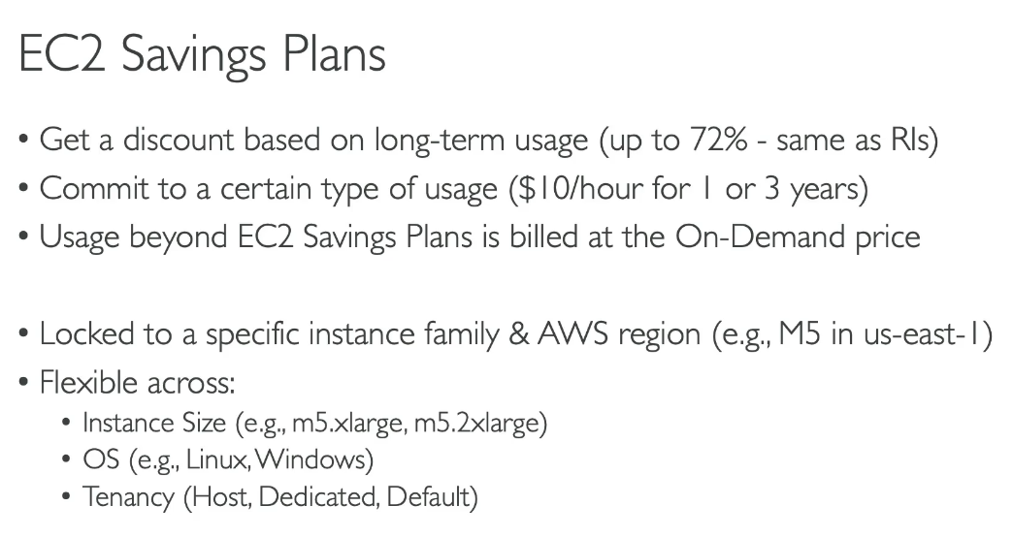

**spot instances**

they have the most aggressive discounts, so up to 90% discounts compared to on-demand, but they are instances you can lose at any point of time because you define a max price you're willing to pay for your spot instances. And if the spot price goes over it, then you're going to lose it. So they're the most cost-efficient instances in AWS and they're going to be very helpful if you have a workload that is resilient to failure.

* Well, it could be batch jobs, data analysis, image processing, any kind of distributed workloads, or workloads that have a flexible start and end time.
* They are not suited for critical jobs or databases and the exam will test you on that.

**Dedicated hosts**

You get an actual physical server with EC2 instances capacity fully dedicated to your use case. And you want to have dedicated hosts in the use case of, you have compliance requirements or you need to use your existing server-bound software licenses that has billing based on a per-socket, per-core, per VM software licenses.This is in these kind of use cases that you need to access the physical server and get a dedicated host.

* So for dedicated hosts, you get on-demand,nand you're gonna pay per second, or you can reserve them for one or three years. They're the most expensive option of AWS because you actually reserve a physical server.
* And so again, a use case is when you have a software that comes with a licensing model that is bring your own license.
* Or if you have a company that has strong regulatory or compliance needs.

**Dedicated instances**,

and there are instances that runs on hardware that's dedicated to you, which is different from the physical server. But you may share the hardware with other instances in the same accounts and you have no control over instance placements. So there's a difference between dedicated instances and hosts, that is here. But remember that dedicated instances mean that you have your own instance on your own hardware, whereas dedicated host, you get access to the physical server itself and it gives you visibility into the lower level hardware.

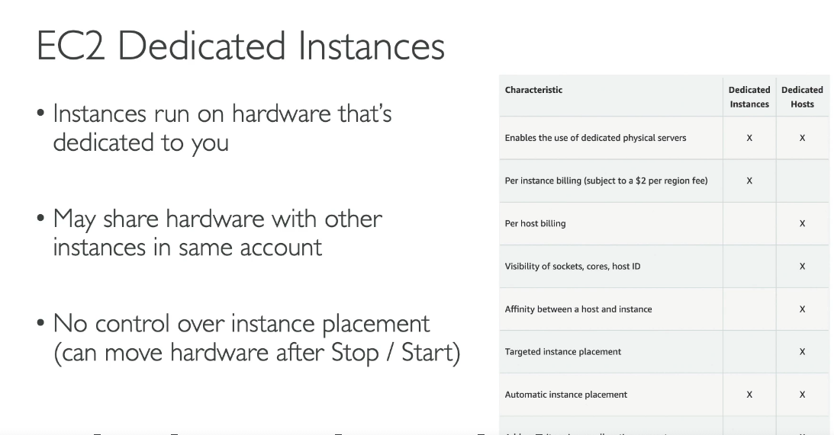

**Capacity reservations**

So you can reserve on-demand instances in a specific AZ for any duration. And then you get access to that capacity whenever you need it. You have no time commitment so you can reserve capacity or cancel your reservation at any time. And no billing discounts. The only purpose is to reserve capacity. So if you want to get billing discounts, you need to combine it with regional reserved instances

or your savings plan. And you're charged at the on-demand rates, whether or not you run instances.

So that means that your reserved capacity, you're going to be billed for it, and you know for sure that if you want to launch instances they're going to be available, but if you don't launch them,you're still going to get charged. So they're very suitable for short-term uninterrupted workloads that need to be in a specific AZ.

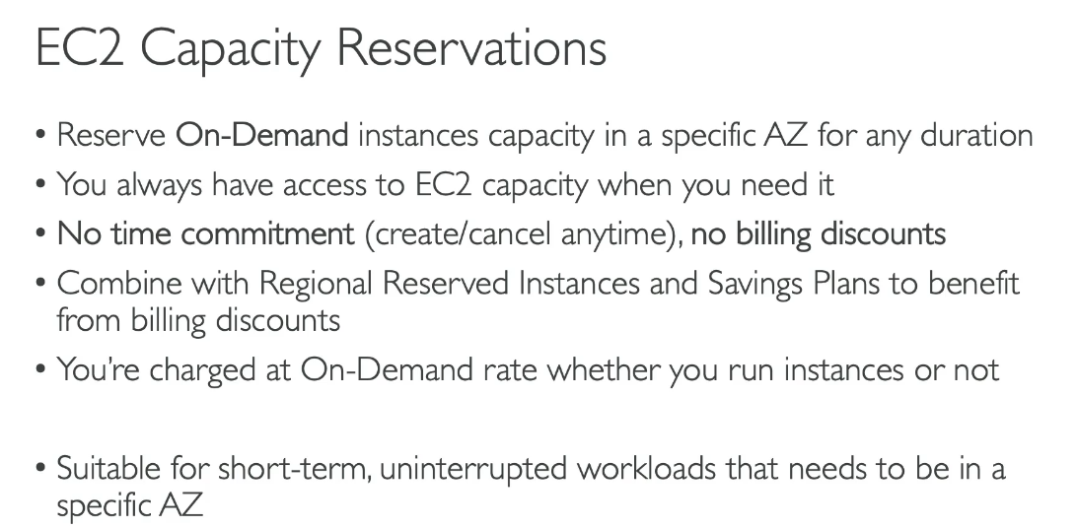

**CHOOSING A PURCHASING OPTION**

So we'll take a resort as an analogy.

**1.on-demand:**you have a resort and you come in whenever you like and whenever you like, you pay the full price.

2. **reserved:** well, you like to plan ahead and you know you're going to stay a very long time in your resort, one, two, three years, and then you're going to get a good discount because we know you're going to stay long time.

3.**Savings plan** is saying,"Hey, I know for sure that in my resort I'm going to spend a specific amount.

So I'm going to spend maybe $300 per month every month for the next 12 months."And therefore, you may wanna change the room type over time. So king, suite, sea view, and so on.But the savings plan is saying, "Hey, you're to commit to a specific spending in your hotel."

4.**Spot instances**: are whenever the hotel runs very last-minute discounts because they have empty rooms and they wanna attract people. So they get empty rooms and people bid on getting this empty room. And so you get very, very discounts.But in this specific resort,well, you can get kicked out of at any time if someone is willing to pay more for your room than what you did.But I don't wanna stay in such a resort.

5.**Dedicated host**: is saying, "Hey, I want to book the entire building of the resort." So you get your own hardware, your own resort.

6.**capacity reservation**: is saying,"I'm going to book a room, I'm not even sure if I don't stay in, but I know that if I want to stay in, I will have it." And you will pay full price for booking that room nonetheless.

